Supplementary Table S1. Baseline Characteristics of the Analytical Sample in 2014
Characteristic | Total (N = 1649), No. (%)
Living arrangement
Living with family | 1300 (78.84)
Living alone | 349 (21.16)
Gender
Male | 822 (49.85)
Female | 827 (50.15)
Education
No education | 519 (31.47)
Attended school but not graduated from primary school | 144 (8.73)
Primary school | 299 (18.13)
Middle school | 297 (18.01)
High school | 129 (7.82)
College or above | 31 (1.88)
Missing | 230 (13.95)
Residence
Urban | 144 (8.73)
Rural | 1290 (78.23)
Missing | 215 (13.04)
Age group, y
67-79 | 974 (59.07)
80-89 | 504 (30.56)
90-99 | 145 (8.79)
≥100 | 26 (1.58)
Age in 2014, y, mean (SD) | 79.47 (7.46)
Data are presented as No. (%) unless otherwise indicated. Minimum age was 67 years.

Supplementary Table S2. Descriptive statistics for community service and cognitive function variables in 2014 (N = 1,649)
Variable | N | Mean | SD | Min | Max
caregiving support | 1649 | 0.047 | 0.212 | 0.000 | 1.000
home visits / house calls | 1649 | 0.319 | 0.466 | 0.000 | 1.000
companionship visits | 1649 | 0.087 | 0.282 | 0.000 | 1.000
help with shopping | 1649 | 0.104 | 0.306 | 0.000 | 1.000
recreation activities | 1649 | 0.203 | 0.402 | 0.000 | 1.000
rights / advocacy services | 1649 | 0.135 | 0.341 | 0.000 | 1.000
education / training | 1649 | 0.429 | 0.495 | 0.000 | 1.000
mediation / coordination | 1649 | 0.284 | 0.451 | 0.000 | 1.000
orientation | 1649 | 0.981 | 0.077 | 0.200 | 1.000
immediate memory | 1649 | 0.949 | 0.180 | 0.000 | 1.000
attention | 1649 | 0.898 | 0.232 | 0.000 | 1.000
delayed recall | 1649 | 0.836 | 0.303 | 0.000 | 1.000
language | 1649 | 0.968 | 0.108 | 0.167 | 1.000

Supplementary Table S3. Descriptive statistics for community service and cognitive function variables in 2018 (N = 1,649)
Variable | N | Mean | SD | Min | Max
caregiving support | 1649 | 0.072 | 0.259 | 0.000 | 1.000
home visits / house calls | 1649 | 0.298 | 0.457 | 0.000 | 1.000
companionship visits | 1649 | 0.116 | 0.321 | 0.000 | 1.000
help with shopping | 1649 | 0.110 | 0.313 | 0.000 | 1.000
recreation activities | 1649 | 0.210 | 0.408 | 0.000 | 1.000
rights / advocacy services | 1649 | 0.189 | 0.392 | 0.000 | 1.000
education / training | 1649 | 0.414 | 0.493 | 0.000 | 1.000
mediation / coordination | 1649 | 0.333 | 0.471 | 0.000 | 1.000
orientation | 1649 | 0.962 | 0.124 | 0.000 | 1.000
immediate memory | 1649 | 0.920 | 0.233 | 0.000 | 1.000
attention | 1649 | 0.820 | 0.320 | 0.000 | 1.000
delayed recall | 1649 | 0.778 | 0.357 | 0.000 | 1.000
language | 1649 | 0.938 | 0.168 | 0.000 | 1.000

Supplementary Table S4. Case-dropping centrality-stability coefficients for cross-lagged panel networks by living arrangement
Centrality index | Living with family | Living alone
Edge weight | 0.543 | 0.344
Bridge expected influence | 0.626 | 0.352
In-expected influence | 0.378 | 0.415
Out-expected influence | 0.626 | 0.272

Supplementary Table S5. Standardized Cross-lagged Panel Network Coefficients (β) for the Living Alone Network From Time 1 to Time 2
T1 variable | T2_CS1 | T2_CS2 | T2_CS3 | T2_CS4 | T2_CS5 | T2_CS6 | T2_CS7 | T2_CS8 | T2_C1 | T2_C2 | T2_C3 | T2_C4 | T2_C5
T1_CS1 | 0.000 | 0.150 | 0.042 | 0.075 | 0.000 | 0.076 | 0.064 | 0.046 | 0.000 | 0.000 | 0.000 | 0.000 | 0.000
T1_CS2 | 0.000 | 0.098 | 0.000 | 0.000 | 0.000 | 0.000 | 0.004 | 0.000 | 0.000 | 0.000 | 0.000 | 0.000 | 0.000
T1_CS3 | 0.084 | 0.000 | 0.099 | 0.153 | 0.003 | 0.029 | 0.019 | 0.028 | 0.000 | 0.000 | 0.000 | 0.000 | 0.000
T1_CS4 | 0.000 | 0.069 | 0.000 | 0.054 | 0.000 | 0.000 | 0.000 | 0.000 | 0.000 | 0.000 | 0.000 | 0.000 | 0.000
T1_CS5 | 0.000 | 0.046 | 0.017 | 0.000 | 0.026 | 0.002 | 0.000 | 0.000 | 0.000 | 0.000 | 0.006 | 0.059 | 0.025
T1_CS6 | 0.000 | -0.038 | 0.000 | 0.024 | 0.042 | 0.000 | 0.037 | 0.000 | 0.000 | 0.000 | 0.033 | 0.000 | 0.000
T1_CS7 | 0.000 | 0.000 | 0.007 | 0.000 | 0.000 | 0.000 | 0.000 | 0.000 | 0.000 | 0.000 | 0.000 | 0.000 | 0.000
T1_CS8 | 0.000 | 0.000 | 0.000 | 0.000 | 0.000 | 0.000 | 0.070 | 0.000 | 0.000 | 0.000 | 0.000 | 0.000 | 0.000
T1_C1 | 0.000 | 0.022 | 0.000 | 0.024 | 0.000 | 0.000 | 0.000 | 0.000 | 0.000 | 0.000 | 0.022 | 0.000 | 0.000
T1_C2 | 0.000 | 0.000 | 0.000 | 0.000 | 0.000 | -0.076 | 0.000 | 0.000 | 0.000 | 0.000 | 0.000 | 0.000 | 0.002
T1_C3 | 0.000 | 0.000 | -0.083 | 0.000 | 0.000 | 0.000 | 0.003 | 0.000 | 0.165 | 0.033 | 0.250 | 0.073 | 0.041
T1_C4 | 0.000 | -0.025 | 0.000 | 0.000 | 0.000 | 0.000 | 0.000 | 0.000 | 0.000 | 0.000 | -0.008 | 0.041 | 0.000
T1_C5 | 0.000 | 0.000 | -0.025 | 0.000 | 0.000 | 0.000 | 0.000 | 0.000 | 0.000 | 0.000 | -0.059 | 0.000 | 0.040

Supplementary Table S6. Standardized Cross-lagged Panel Network Coefficients (β) for the co-residing Network From Time 1 to Time 2
T1 variables | T2_CS1 | T2_CS2 | T2_CS3 | T2_CS4 | T2_CS5 | T2_CS6 | T2_CS7 | T2_CS8 | T2_C1 | T2_C2 | T2_C3 | T2_C4 | T2_C5
T1_CS1 | 0.000 | 0.000 | 0.000 | 0.000 | 0.041 | 0.020 | 0.000 | 0.000 | 0.000 | 0.000 | 0.000 | 0.047 | 0.000
T1_CS2 | 0.000 | 0.067 | 0.000 | 0.000 | 0.010 | 0.006 | 0.048 | 0.038 | 0.000 | 0.000 | 0.000 | 0.026 | 0.000
T1_CS3 | 0.000 | 0.000 | 0.034 | 0.000 | 0.055 | 0.057 | 0.004 | 0.042 | 0.000 | 0.000 | 0.000 | 0.008 | 0.000
T1_CS4 | 0.000 | 0.000 | -0.010 | 0.000 | -0.064 | -0.044 | 0.000 | -0.051 | 0.000 | 0.000 | 0.000 | 0.063 | 0.036
T1_CS5 | 0.000 | 0.019 | 0.087 | 0.000 | 0.098 | 0.058 | 0.000 | 0.013 | 0.015 | 0.000 | 0.004 | 0.000 | 0.000
T1_CS6 | 0.000 | 0.000 | 0.000 | 0.000 | 0.000 | 0.056 | 0.002 | 0.077 | 0.000 | 0.000 | 0.000 | -0.006 | 0.000
T1_CS7 | 0.000 | 0.042 | 0.000 | 0.000 | 0.048 | 0.008 | 0.082 | 0.039 | 0.000 | -0.003 | 0.000 | 0.000 | -0.039
T1_CS8 | 0.058 | 0.000 | 0.002 | 0.017 | 0.040 | 0.056 | 0.010 | 0.056 | 0.000 | 0.000 | 0.000 | -0.073 | 0.000
T1_C1 | 0.000 | 0.000 | 0.000 | 0.000 | 0.000 | 0.013 | 0.000 | -0.012 | 0.131 | 0.083 | 0.096 | 0.065 | 0.079
T1_C2 | 0.000 | 0.000 | 0.000 | 0.000 | -0.019 | -0.023 | 0.000 | -0.013 | 0.000 | 0.091 | 0.000 | 0.046 | 0.011
T1_C3 | 0.030 | 0.000 | 0.023 | 0.000 | 0.027 | 0.032 | 0.000 | 0.027 | 0.039 | 0.055 | 0.241 | 0.060 | 0.091
T1_C4 | 0.000 | 0.000 | 0.000 | 0.000 | 0.000 | -0.007 | 0.000 | -0.034 | 0.071 | 0.039 | 0.000 | 0.106 | 0.000
T1_C5 | 0.000 | 0.000 | 0.000 | 0.000 | 0.025 | 0.039 | 0.000 | 0.019 | 0.000 | 0.102 | 0.038 | 0.055 | 0.140

Supplementary Figure S1: Love plot of baseline covariate balance: eligible T1 cohort vs. final analytic sample after attrition and listwise deletion
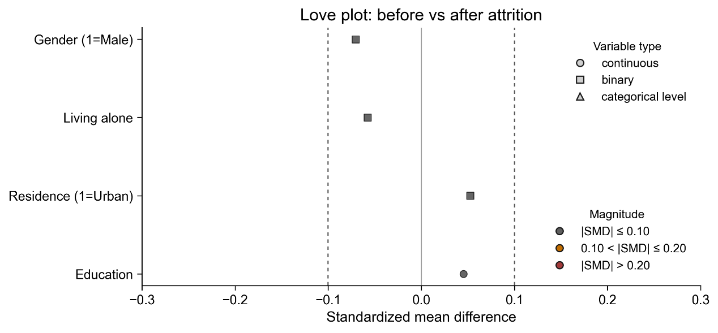
Points denote covariates (gender, living alone, residence, education); shapes indicate variable type (circle = continuous, square = binary). The vertical dashed lines at ±0.10 mark a conventional threshold for negligible imbalance. All covariates fall within ±0.10, indicating that attrition and listwise deletion did not materially alter the composition of the T1 baseline sample.

Supplementary Figure S2: Nonparametric Bootstrap of CLPN Edge Weights (living alone)
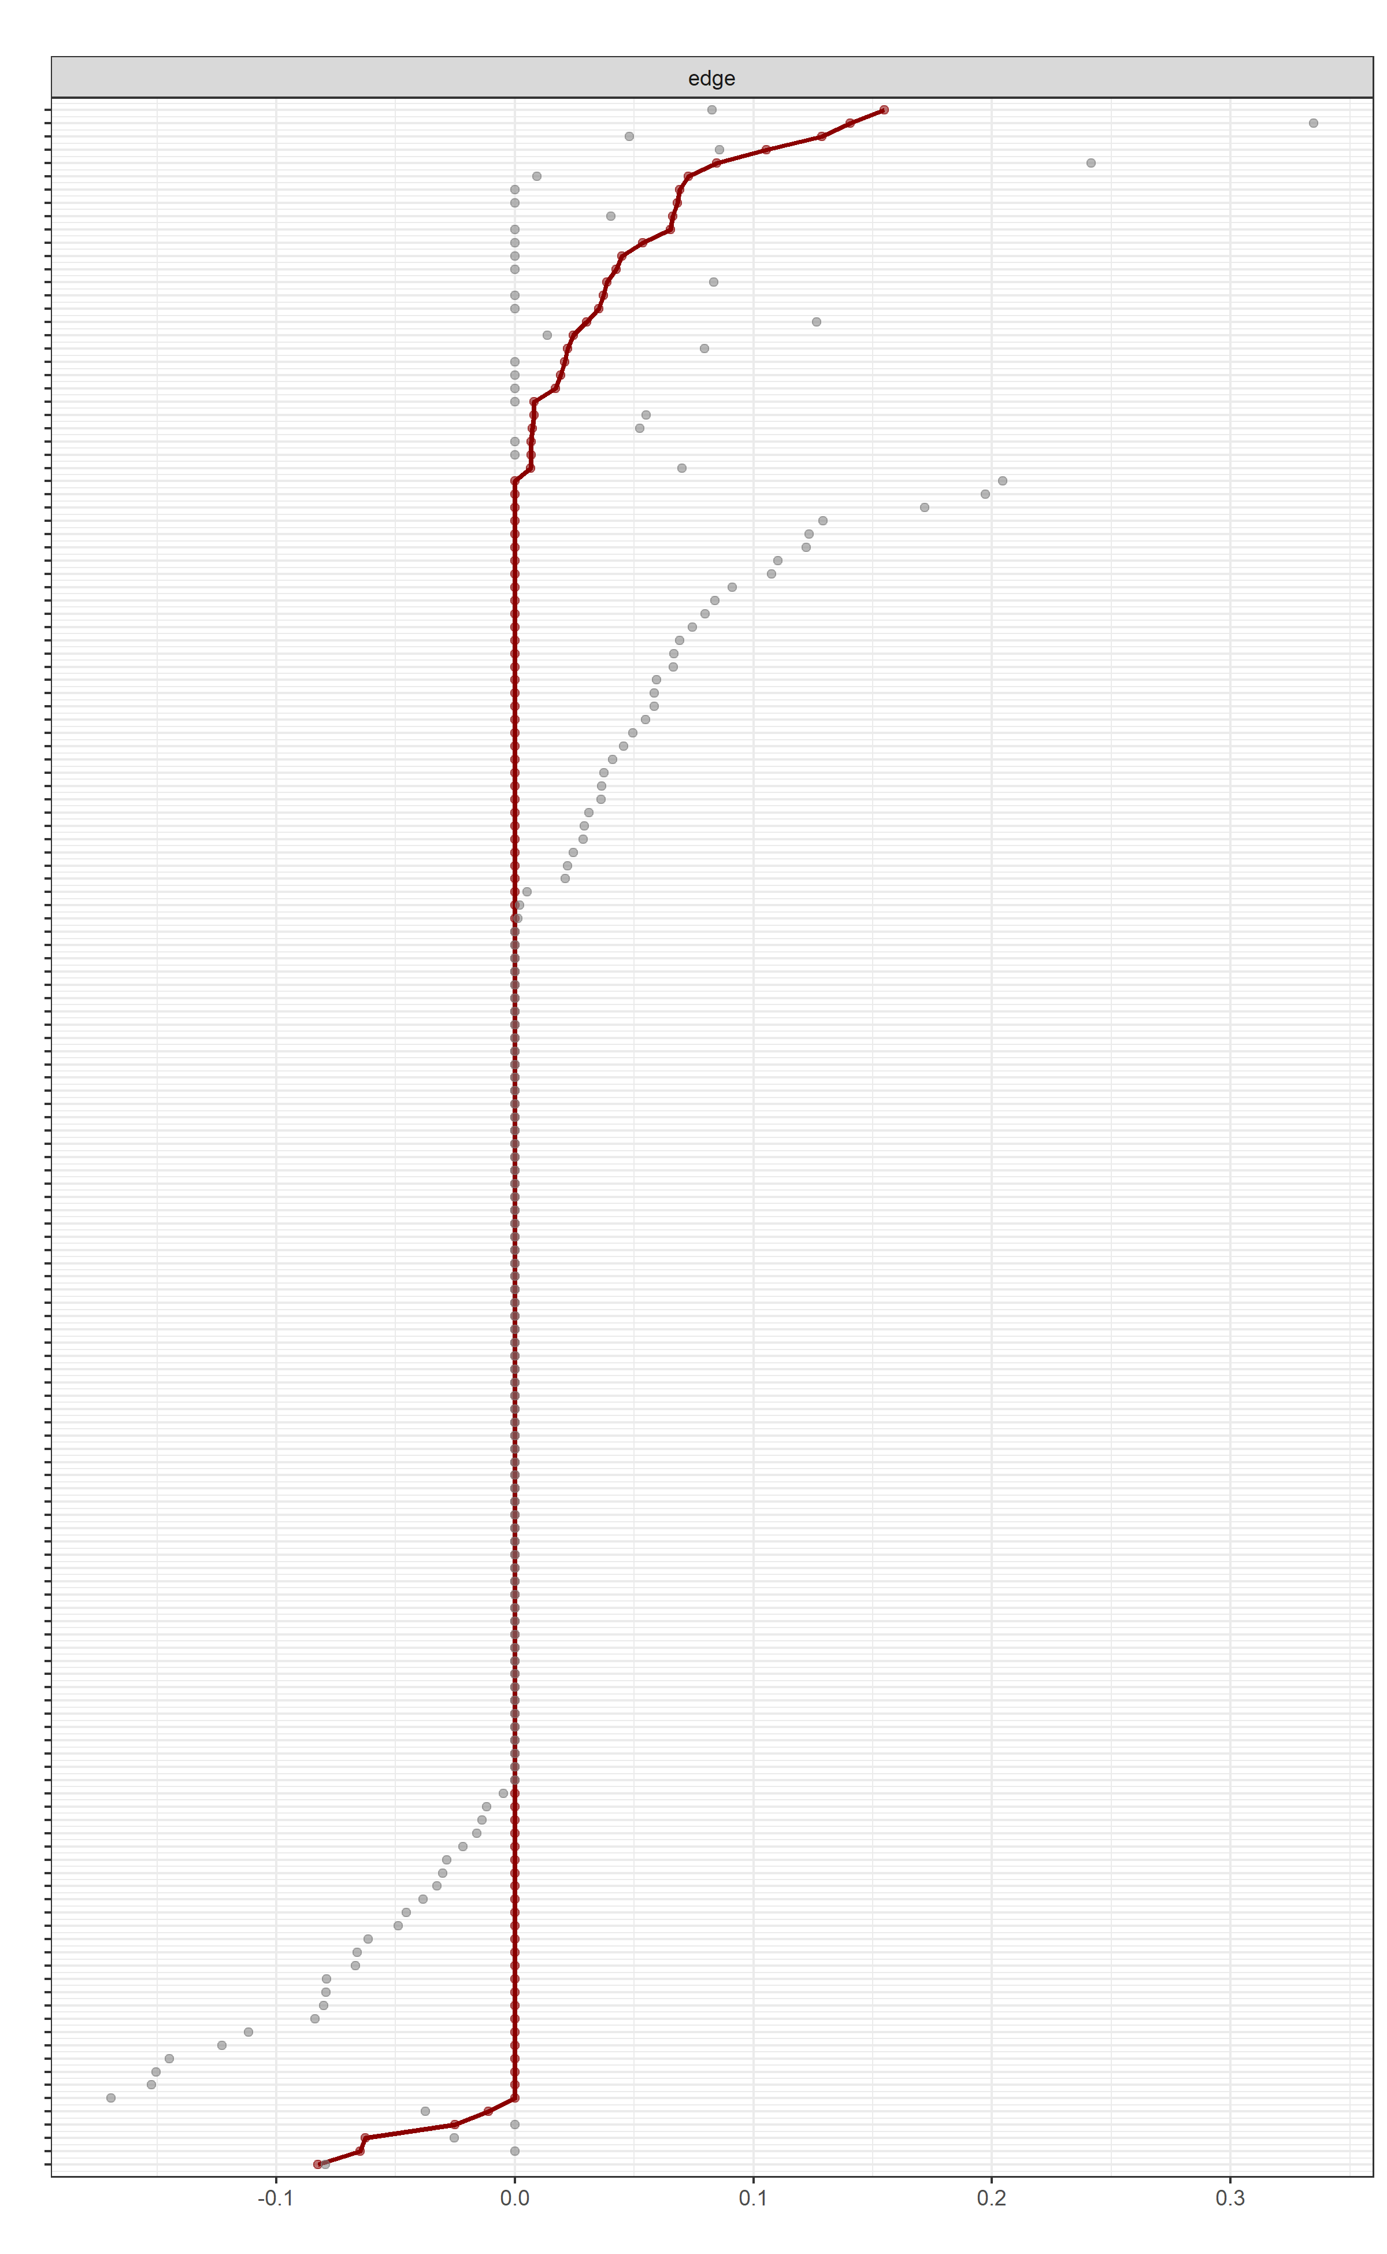
Gray bands show the nonparametric bootstrap distributions with 95% CIs for each directed edge weight, ordered by the sample estimate, and the red trace marks the corresponding estimate from the original network (x-axis = standardized β).

Supplementary Figure S3: Nonparametric Bootstrap of CLPN Edge Weights (co-residing)
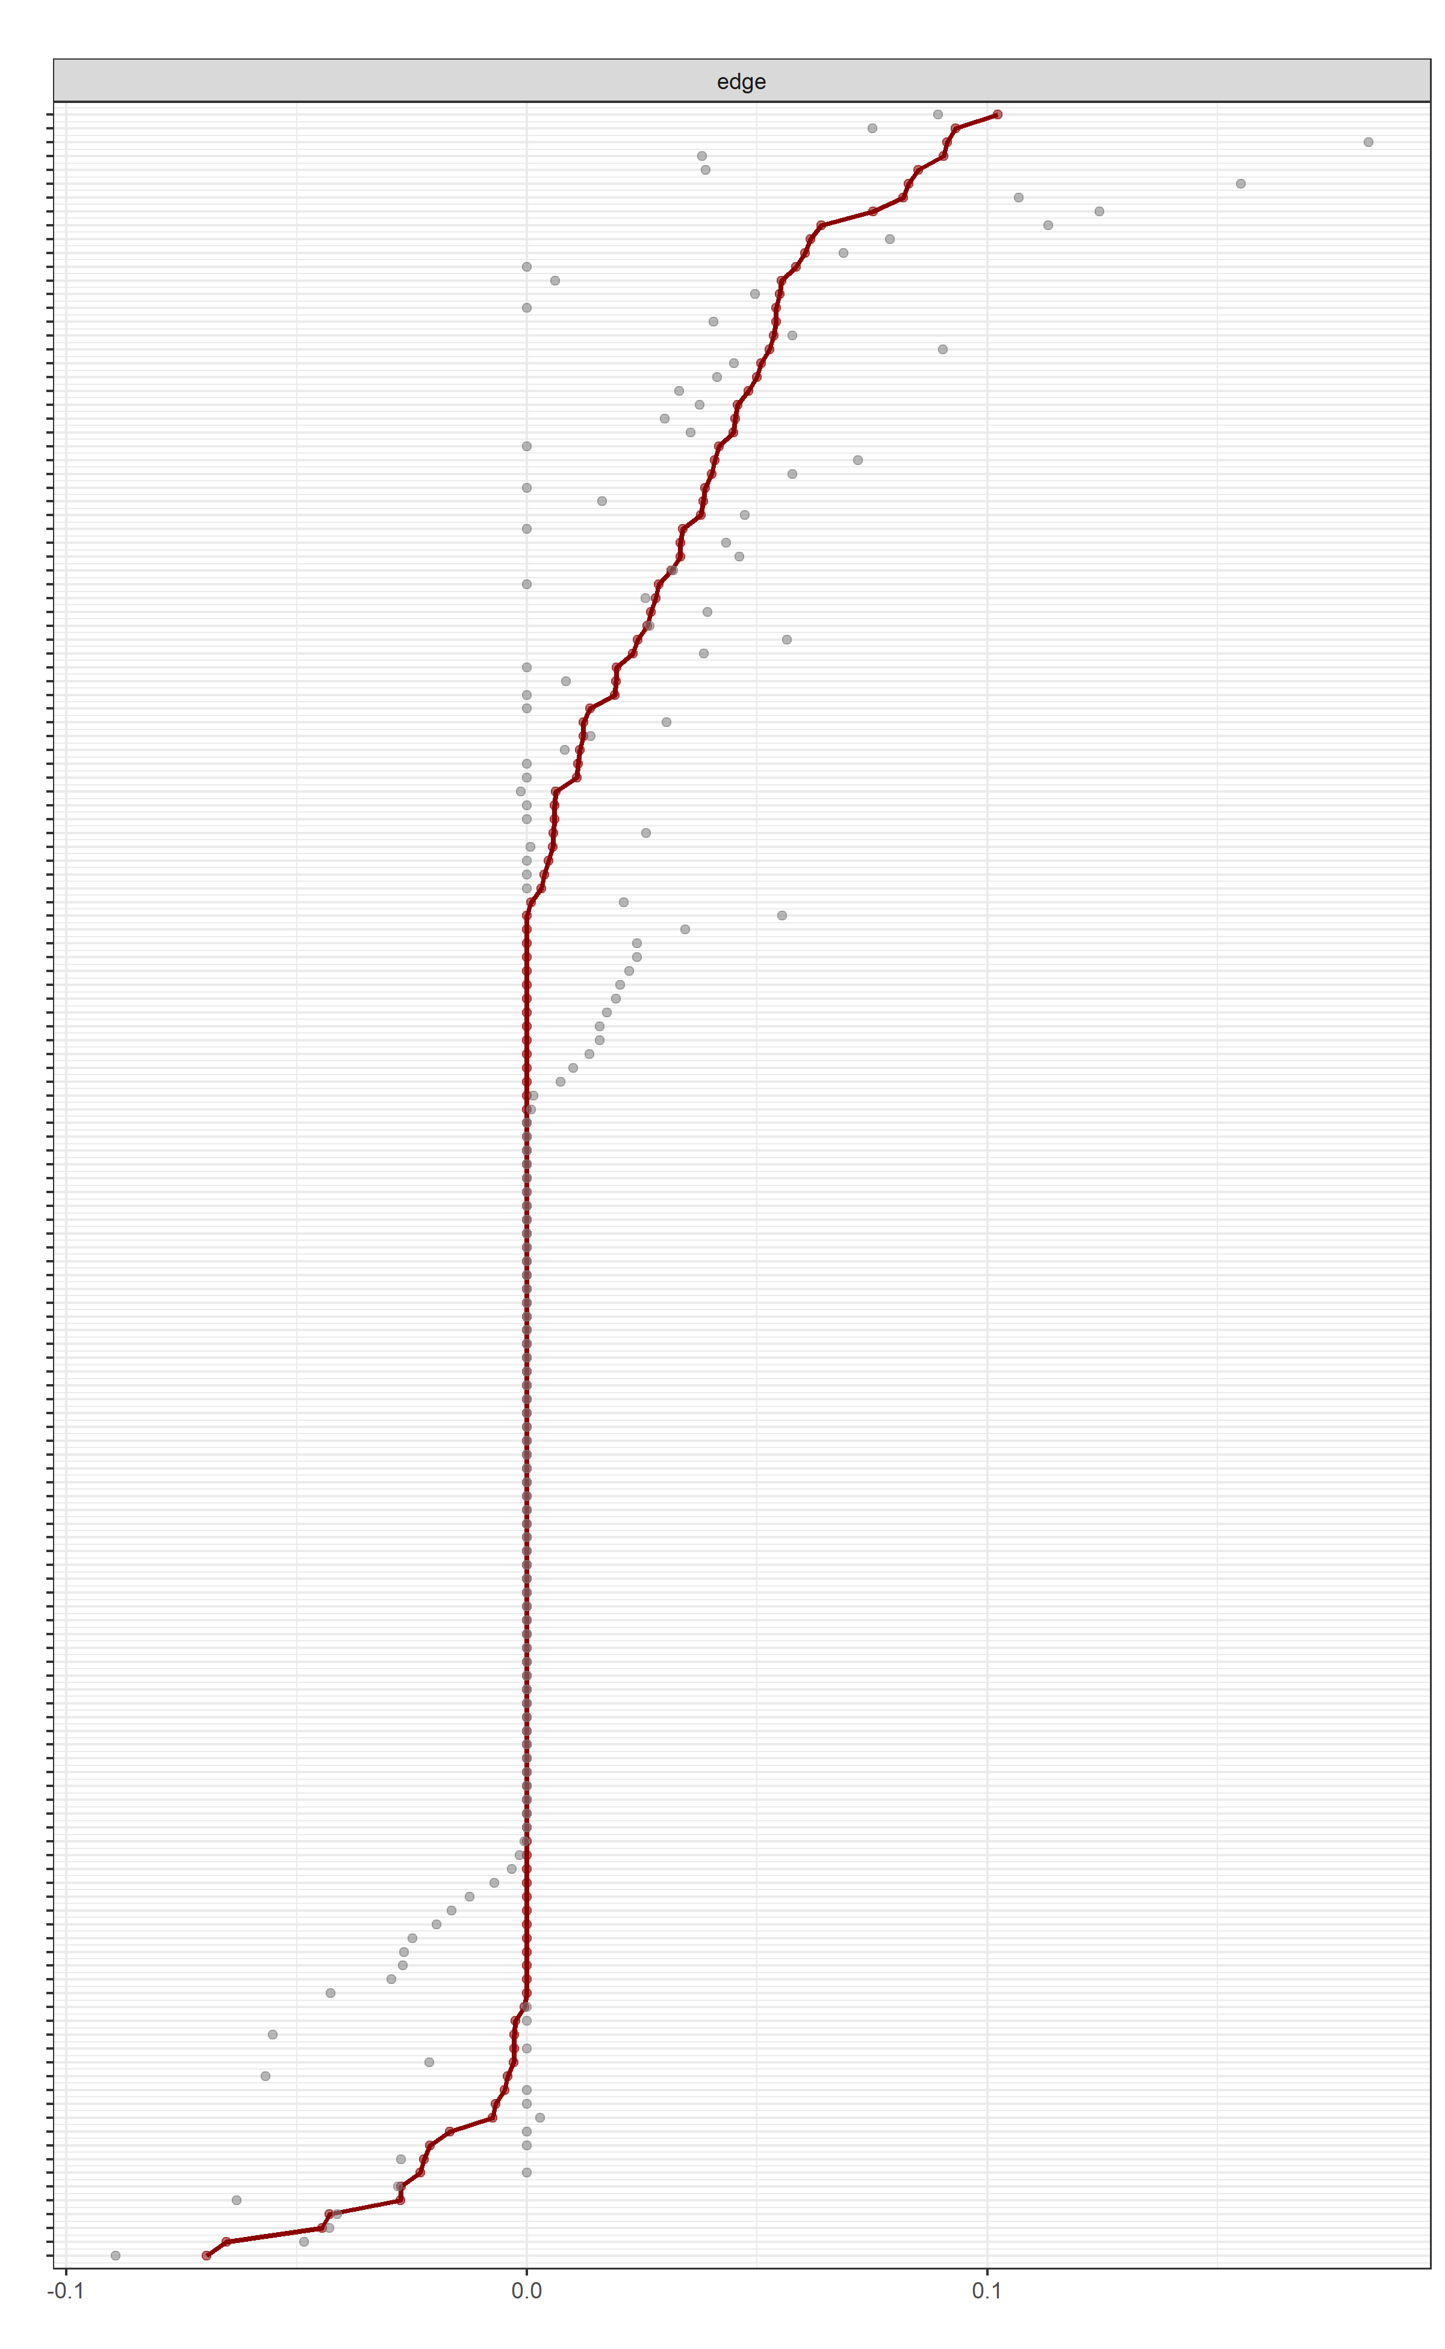
Supplementary Figure S4: Case-Dropping Bootstrap Stability of CLPN Edges and Centrality Indices (living alone)
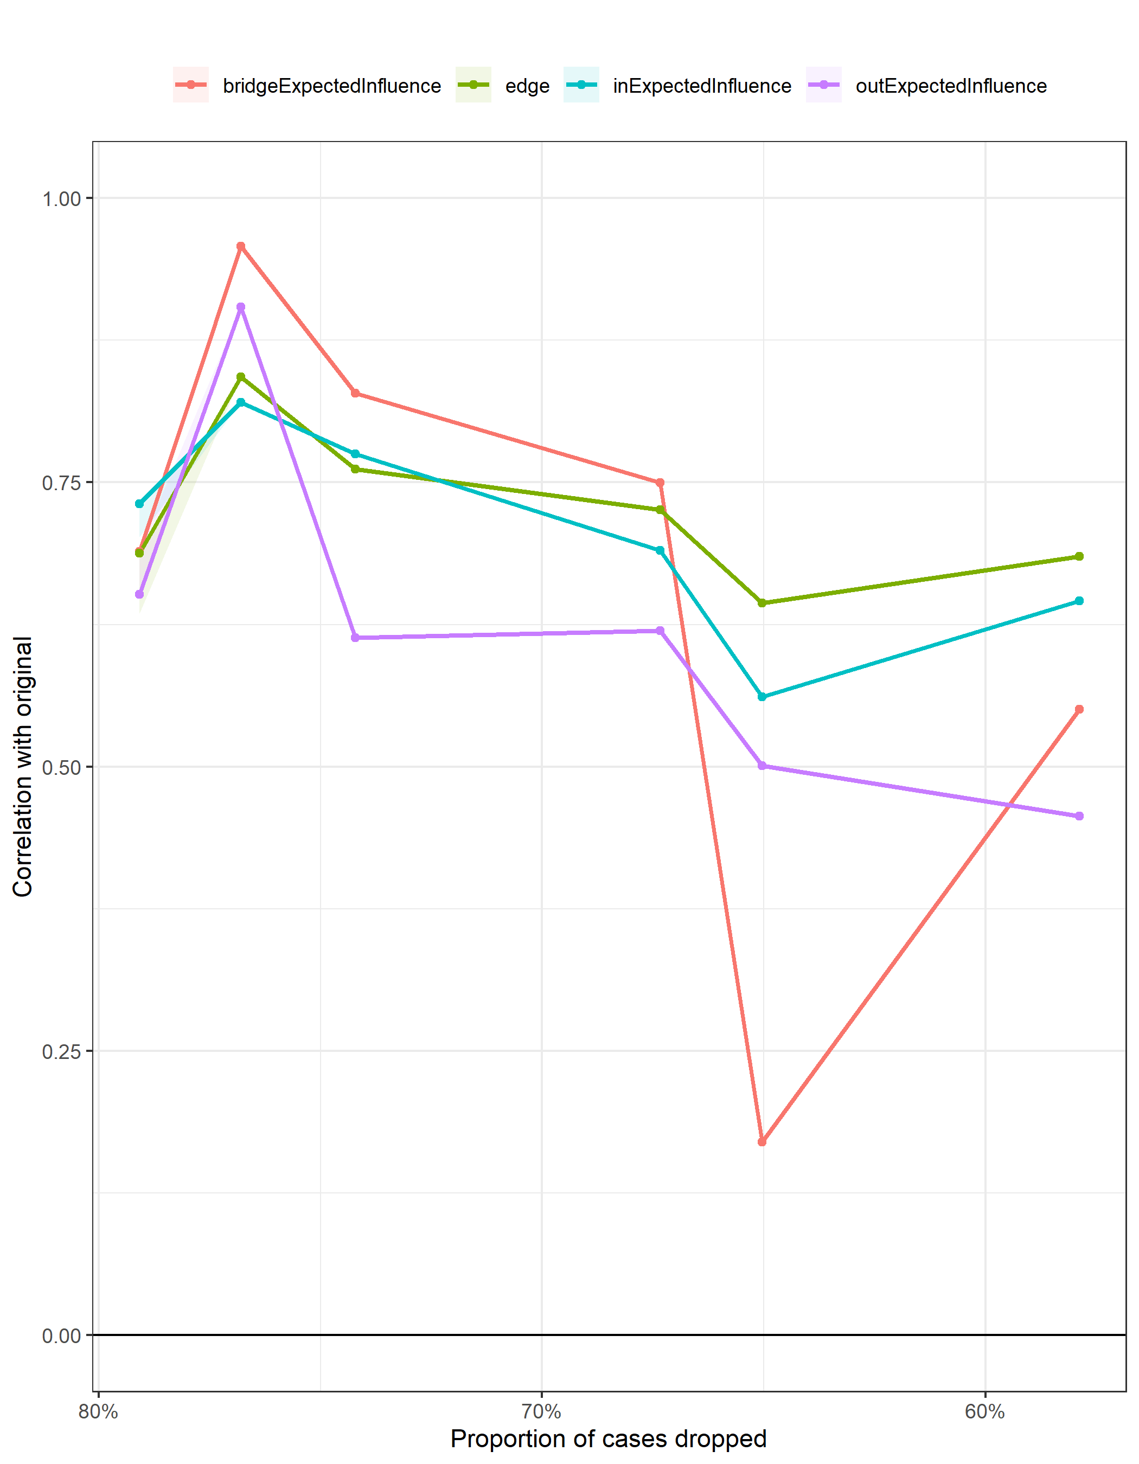
Lines show the mean correlation with the original estimates (y-axis) as a function of the proportion of cases dropped (x-axis) for edges, in-expected influence, out-expected influence, and 1-step bridge expected influence, with ribbons denoting 95% bootstrap quantiles.

Supplementary Figure S5: Case-Dropping Bootstrap Stability of CLPN Edges and Centrality Indices (co-residing)
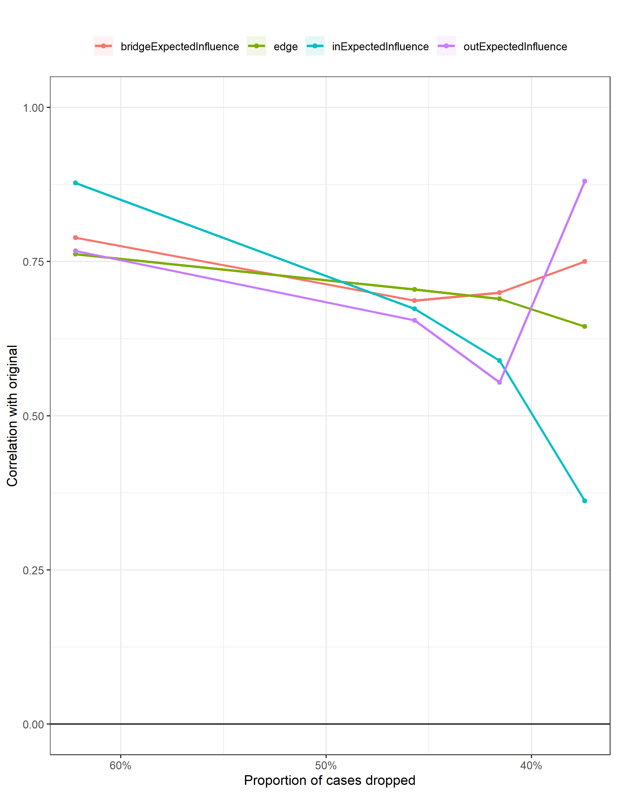

Lines show the mean correlation with the original estimates (y-axis) as a function of the proportion of cases dropped (x-axis) for edges, in-expected influence, out-expected influence, and 1-step bridge expected influence, with ribbons denoting 95% bootstrap quantiles.

